**VISVESVARAYA TECHNOLOGICAL UNIVERSITY**

**Jnana Sangama, Belagavi-590010**



DBMS MINI PROJECT REPORT

ON

“Gym Management System”

**BACHELOR OF ENGINEERING**

**IN**

**COMPUTER SCIENCE AND ENGINEERING**

For the Academic Year 2021-2022 Submitted by:

**Abhigyan Singh 1MV19CS002**

**Anurag Yadav 1MV19CS016**

Under the guidance of:

**Dr. Suma Swamy**

Professor, Department of CSE

Sir M. Visvesvaraya Institute of Technology, Bengaluru



**DEPARTMENT OF COMPUTER SCIENCE AND ENGINEERING**

**SIR M. VISVESVARAYA INSTITUTE OF TECHNOLOGY**

HUNASAMARANAHALLI, BENGALURU-562157

# SIR M. VISVESVARAYA INSTITUTE OF TECHNOLOGY

Krishnadevaraya Nagar, International Airport Road,

Hunasmaranahalli, Bengaluru – 562157

## DEPARTMENT OF COMPUTER SCIENCE AND ENGINEERING



**CERTIFICATE**

It is certified that the **DBMS Mini Project work** entitled " Gym Management System" is carried out by **Abhigyan Singh(1MV19CS002) , Anurag Yadav(1MV19CS016)** bonafide students of **Sir M Visvesvaraya Institute of Technology** in partial fulfillment for the 5th semester for the award of the Degree of Bachelor of Engineering in Computer Science and Engineering of the **Visvesvaraya Technological University, Belagavi** during the academic year **2021-2022**.It is certified that all corrections and suggestions indicated for Internal Assessment have been incorporated in the report deposited in the department library. The project report has been approved as it satisfies the academic requirements in respect of project work prescribed for the course of Bachelor of Engineering.

Name & Signature Name & Signature Name & Signature

of Guide of HOD of Principal

**Dr . Suma Swamy**  **Dr. G. C. Bhanu Prakash** **Dr. V.R. Manjunath**

|  |  |  |
| --- | --- | --- |
| Prof & Internal Guide | HOD, Dept. Of CSE, | Principal, |
| Dept. Of CSE, Sir MVIT | Sir MVIT | Sir MVIT |
| Bengaluru - 562157  External Examination: | Bengaluru - 562157 | Bengaluru – 562157 |
| Name of Examiner |  | Signature with Date |

1)

2)

# DECLARATION

We hereby declare that the entire project work embodied in this dissertation has been carried out by us and no part has been submitted for any degree or diploma of any institution previously.

Place: Bengaluru Date:

Signature of Students:

Abhigyan Singh Anurag Yadav

(1MV19CS002) (1MV19CS016)

# ACKNOWLEDGMENT

It gives us immense pleasure to express our sincere gratitude to the management of **Sir M. Visvesvaraya Institute of Technology,** Bengaluru for providing the opportunity and the resources to accomplish our project work in their premises.

On the path of learning, the presence of an experienced guide is indispensable and we would like to thank our guide **Dr Suma Swamy,** Professor, Dept. of CSE, for her invaluable help and guidance.

Heartfelt and sincere thanks to **Dr. G. C. Bhanu Prakash,** HOD, Dept. of CSE, for his suggestions, constant support and encouragement.

We would also like to convey our regards to **Dr. V.R. Manjunath,** Principal, Sir.

MVIT for providing us with the infrastructure and facilities needed to develop our project.

We would also like to thank the staff of Department of Computer Science and Engineering and lab-in-charges for their co-operation and suggestions. Finally, we would like to thank all our friends for their help and suggestions without which completing this project would not have been possible.

Abhigyan Singh 1MV19CS002

Anurag Yadav 1MV19CS016

# CONTENTS

Chapters

1. Introduction
   1. Introduction to Gym Management System
   2. Sections of the project
   3. Features of the project
   4. Objectives
2. Front End and Back End
   1. Sections
   2. Front-End
   3. Back-End
3. Specifications and System Requirements
4. System Design
   1. Conceptual Database Design (ER-Diagram)
5. Front End Design, Connectivity and Implementation
   1. Front-End details
   2. Connectivity(Front End and Back End)
6. Output Snapshots
7. Application and Future Scope
8. Conclusion
9. References

## CHAPTER - 1

## INTRODUCTION

**1.1 Introduction to Gym Management System :**

* Gym Management System is an administrative interface for the records of the gym, gym members, gym trainers, and payments.
* Gym management system helps fitness owners and operators manage their class and trainers, keep track of their members, communicate with clients, and record payments.
* This system helps the Owner and Admin to maintain large data about users and their respective transactions in the gymnasium

**Features :**

* Gyms Management
* Gym Members Management
* Payment Management
* Trainer Management

**1.2 About the Project:**

Gym Management System developed using PHP is an excellent solution for gyms with a large/growing number of members, or ones serving elite clientele. This solution helps to identify the user and manage their timely memberships.

In its working, each member is issued a membership card which is valid for a fixed number of gym sessions, or for a particular period of time, or a combination of the two, totally based on the payment policy. Once the time-frame or number of sessions expire, the machine notifies the member about the payment of renewal.

Hence, the system reduces hassle and any chances of quarrels between the members and the gym management. It can also generate multiple reports like monthly, weekly, daily, session wise.

**1.3 Main features are:**

1. Gyms Management
2. Gym Members Management
3. Payment Management
4. Trainers Management

**1.4 Objectives:**

1. Add different gyms.
2. Add payment areas.
3. Add members to gym.
4. Add different trainers of gym.
5. View different gyms.
6. View payment areas.
7. View members to gym.
8. View different trainers of gym.
9. Update and delete different values of gyms, payments made, gym member’s details and trainer’s information.

# CHAPTER – 2 Front End and Back End

**2.1 Sections** :

The project consists of two main sections:

Backend: codes that are written in python, PHP, ASP .net to name but a few by the developer

Frontend: which is markup showed by clients or users browsers, and for doing this we should use HTML (Hyper Text Markup Language), it just shows some elements for users and doesn't run any functions. When you go to a specific URL, your request is sent to your desired server and it'll render for your HTML of the site, in fact, the server runs any server -side functions.

**2.2 Front-End** :

The Front -End used in this project is HTML along with the CSS language.

* HTML stands for Hyper Text Markup Language
* HTML is the standard markup language for creating Web pages.
* HTML describes the structure of Web pages using markup
* HTML elements are the building blocks of HTML pages
* HTML elements are represented by tags
* HTML tags label pieces of content such as "heading", "paragraph", "table", and so on
* Browsers do not display the HTML tags, but use them to render the content of the page

**Advantages of HTML:**

1. The first advantage it is widely used.
2. Every browser supports HTML language.
3. Easy to learn and use.
4. It is by default in every window so you don't need to purchase extra software.
5. You can integrate HTML with CSS, JavaScript, PHP etc.

**2.3 Back-End :**

The back -end database used in this project is MySQL

It is a language used to interrogate and process data in a relational database. Originally developed by IBM for its mainframes, SQL commands can be used to interactively work with a database or can be embedded within a script or programming language as an interface to a database. Programming extensions to SQL have turned it into a full-blown database programming language, and all major database management systems (DBMSs) support it. ANSI standardized SQL.

But most DBMSs have some proprietary enhancement, which if used, makes SQL nonstandard. Moving an application from one SQL database to another sometimes requires tweaking, the age-old problem in this business!

**Advantages of MySQL:**

1. SQL Queries can be used to retrieve large amounts of records from a database quickly.
2. SQL is used to view the data without storing the data into the object

3.SQL joins two or more tables and show it as one object to user

4.SQL databases use long-established standard, which is being adopted by ANSI &amp; ISO. Non -SQL databases do not adhere to any clear standard.

5.Using standard SQL, it is easier to manage database systems without having to write substantial amount of code

# CHAPTER - 3 SPECIFICATIONS

**SYSTEM REQUIREMENTS**

* 1. **Hardware Requirements:**

The section of hardware configuration is an important task related to the software development insufficient random-access memory may affect adversely on the speed and efficiency of the entire system. The process should be powerful to handle the entire operation.

The hard disk should have capacity to store the file and application.

* Processer: Intel Dual Core and above
* Hard Disk: 80GB or more
* RAM: 512 MB

**3.2 Software Requirements** :

A major element in building a system is the section of compatible software since the software is the market is experiencing in geometric progression. Selected software should be acceptable by the firm and one user as well as it should be feasible for the system. This document gives a detailed description of the software requirement specification. The study of requirement specification is focused specially on the functioning of the system. It allows the developer or analyst to understand the system, function to be carried out the performance level to be obtained and corresponding interfaces to be established.

* Operating System: Window7, Window8 and above
* Front End: HTML
* Back End: MYSQL
* Server-Side Programming: PHP
* Server: Xampp

## 4 SYSTEM DESIGN

### 4.1 Conceptual Database Design (UML-Diagram)

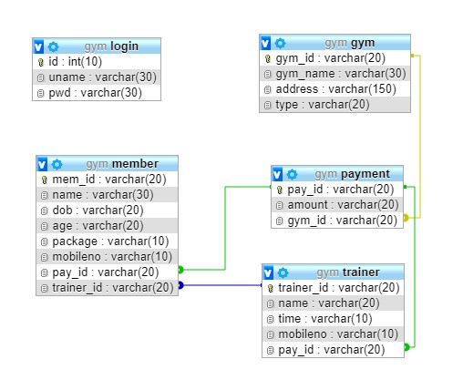

### 4.2 Conceptual Database Design (ER-Diagram)

# 5 Front End Design, Connectivity and

# Implementation

**5.1 Front-end web development details**

* **HTML** provides the basic structure of sites, which is enhanced and modified by other technologies like CSS and JavaScript.
* **CSS** is used to control presentation, formatting, and layout.
* **JavaScript** is used to control the behaviour of different elements.

## HTML

HTML is at the core of every web page, regardless the complexity of a site or number of technologies involved. It's an essential skill for any web professional. It's the starting point for anyone learning how to create content for the web. And, luckily for us, it's surprisingly easy to learn.

## CSS

CSS stands for Cascading Style Sheets. This programming language dictates how the HTML elements of a website should actually appear on the frontend of the page.

## JavaScript

JavaScript is a more complicated language than HTML or CSS, and it wasn't released in beta form until 1995. Nowadays, JavaScript is supported by all modern web browsers and is used on almost every site on the web for more powerful and complex functionality.

**5.2 Connectivity (front end and Back end):**

PHP is an amazing and popular language!

It is powerful enough to be at the core of the biggest blogging system on the web (Word Press)! It is deep enough to run the largest social network (Facebook)! It is also easy enough to be a beginner's first server side language!

* PHP is an acronym for "PHP: Hypertext Pre-processor"
* PHP is a widely-used, open source scripting language
* PHP scripts are executed on the server
* PHP is free to download and use
* PHP files can contain text, HTML, CSS, JavaScript, and PHP code
* PHP code are executed on the server, and the result is returned to the browser as plain HTML

# CHAPTER - 6

## OUTPUT SNAPSHOTS

### ADMIN PAGE

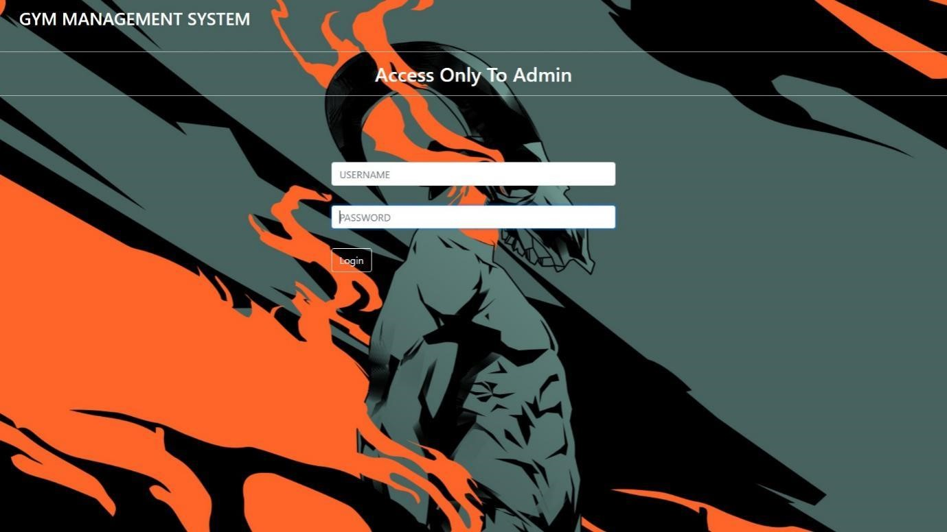

### ADD GYM

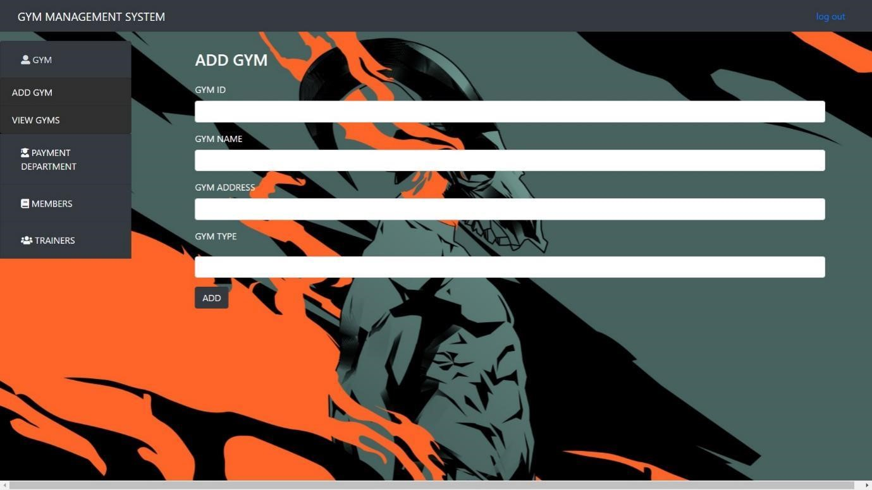

### MANAGE GYM

**ADD PAYMENT AREA**

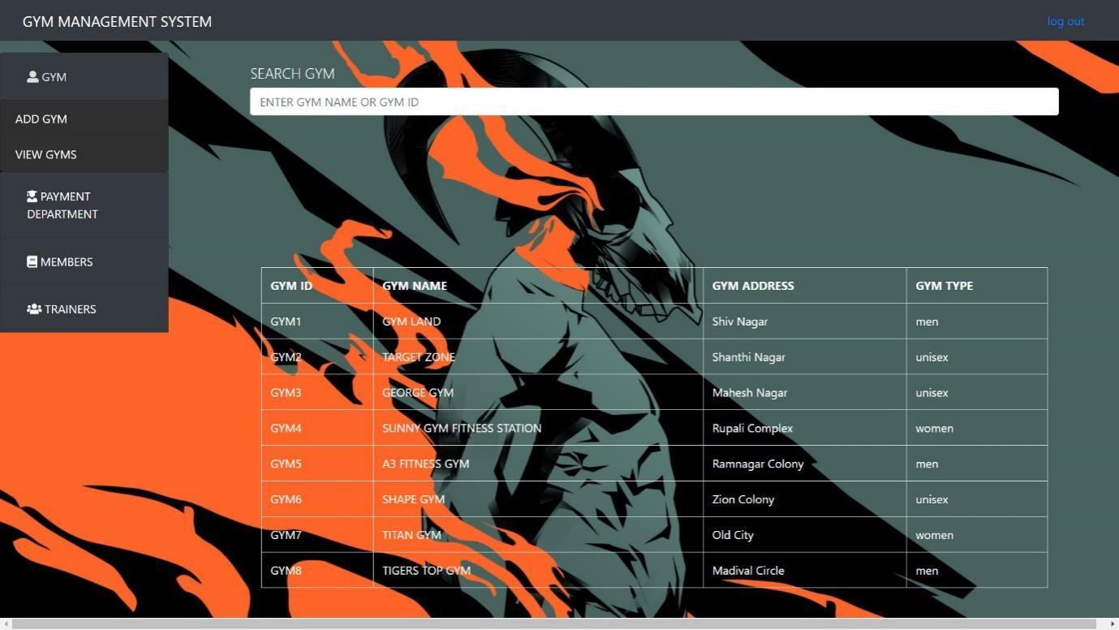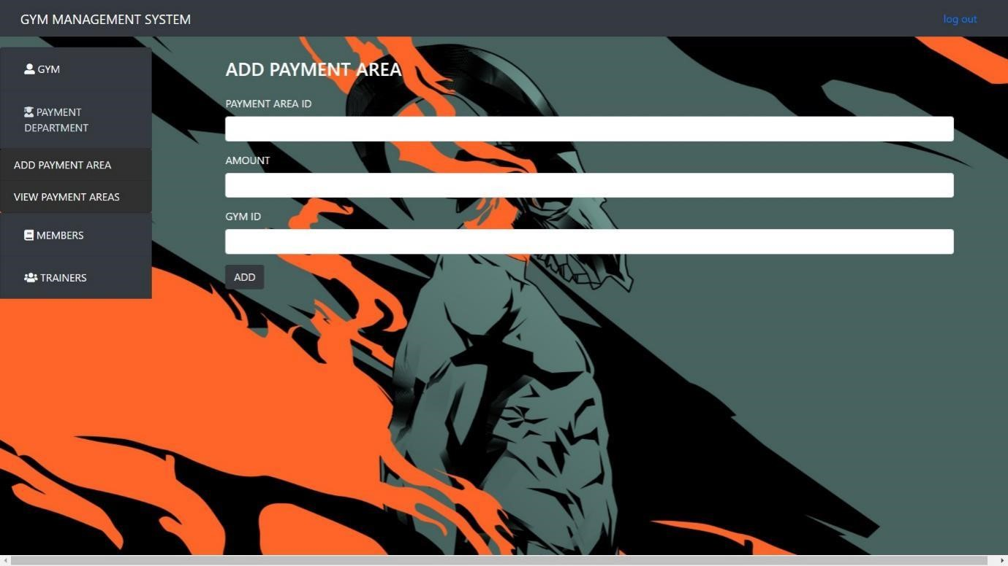

### MANAGE PAYMENT AREA

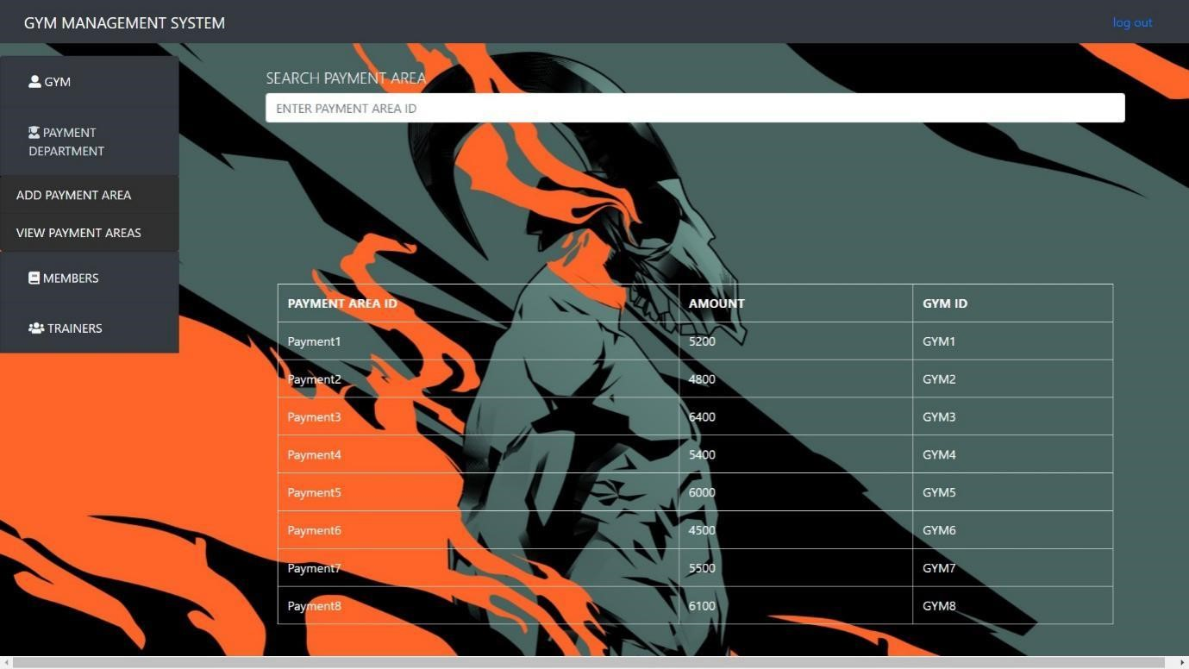

### ADD MEMBER

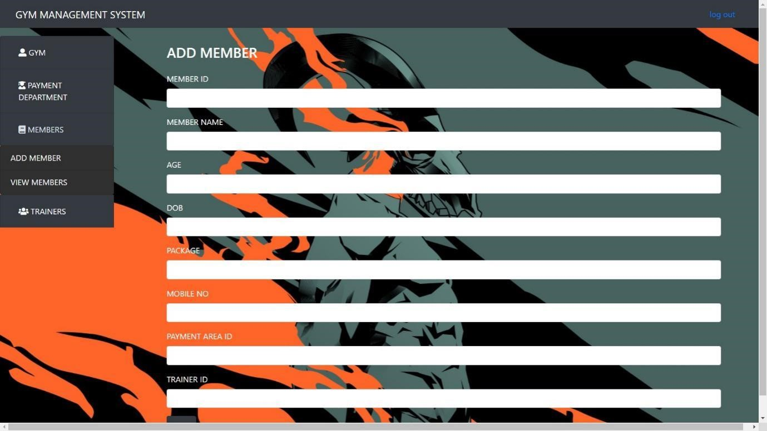

### MANAGE MEMBER

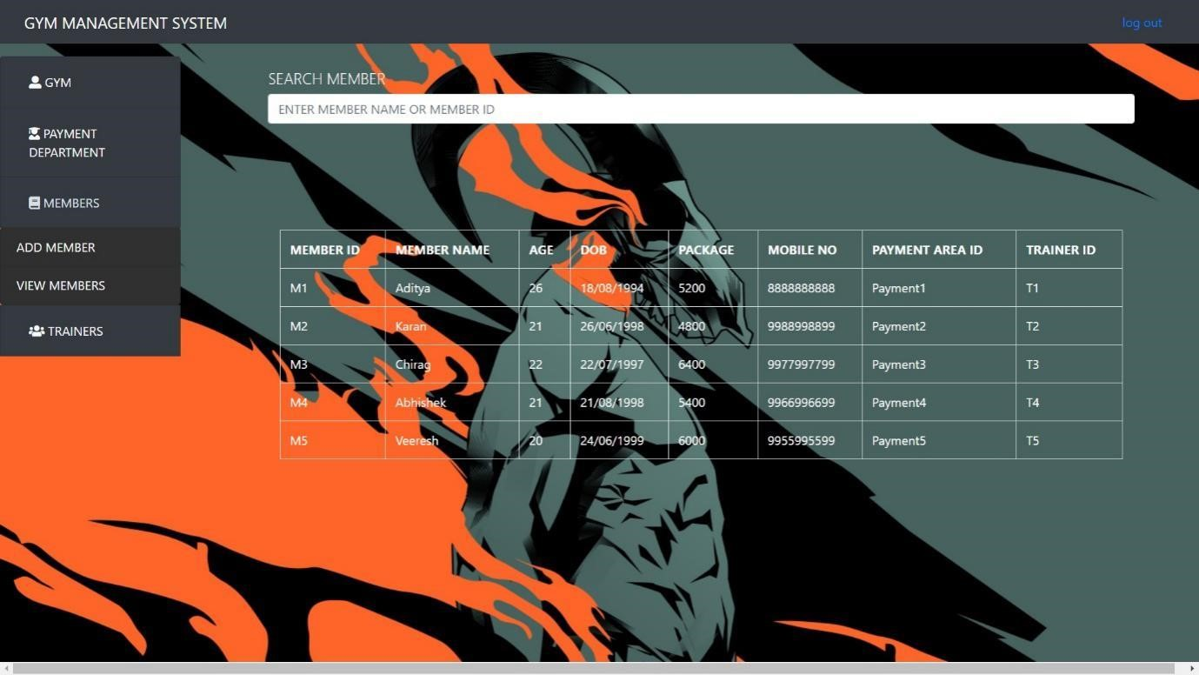

### ADD TRAINER

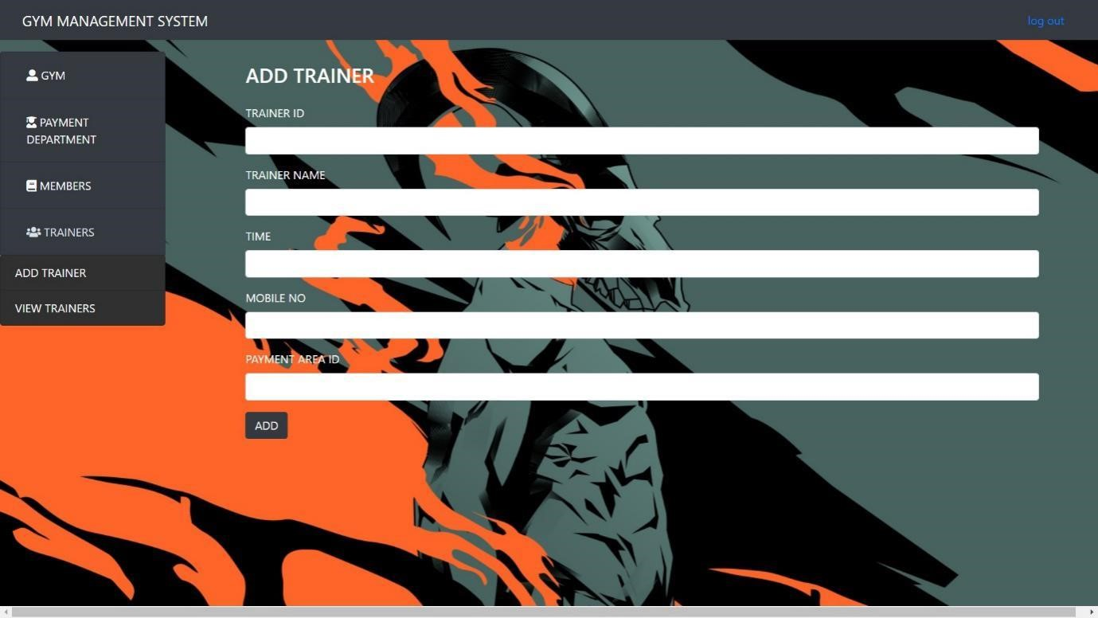

### MANAGE TRAINER

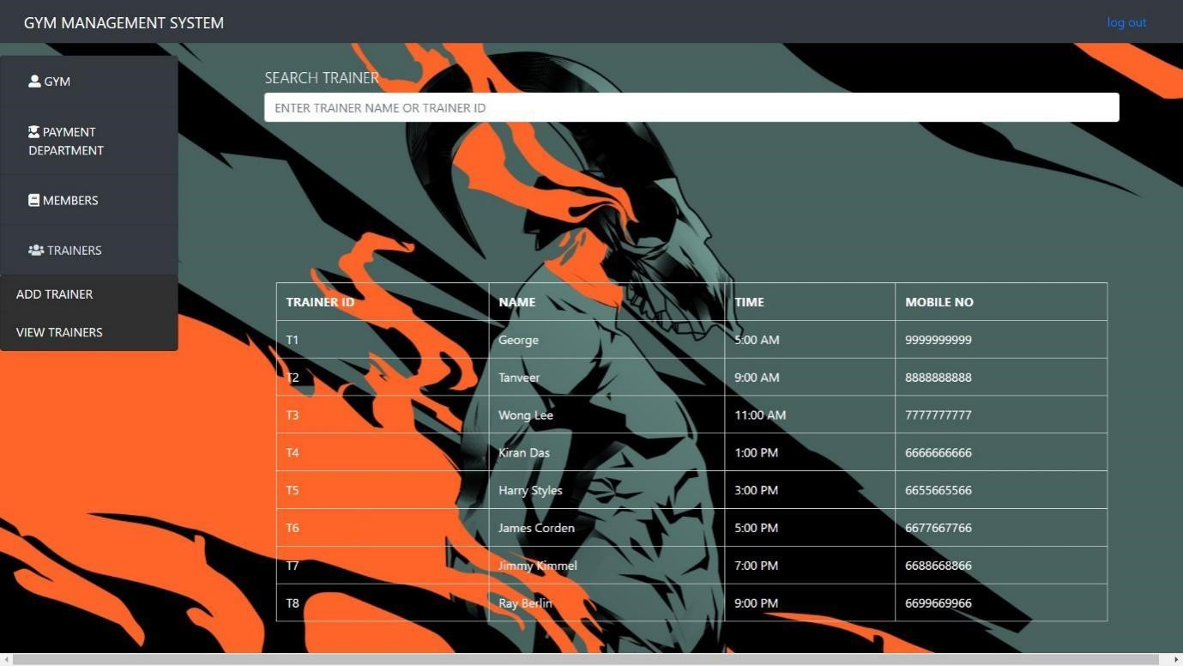

# CHAPTER -7 APPLICATION AND FUTURE SCOPE

Gym management system is designed to simplify the running of a fitness club.

Without gym member management system, all tasks will need to be carried separately. For example, you may manage billing through one piece of software, keep track of administrative tasks somewhere else, and use a spreadsheet for financial forecasting. You may have member management information online or offline in the office. Either way, there is no one centralized spot where you can find all the information about your business. Gym management system is designed to streamline operations so that all of these tasks can be in one place.

From online gym scheduling and automated billing to administrative tasks, the software pulls all data into one place so that you can run your business more efficiently.

1. A Streamlined Dashboard

Look for a dashboard this is naturally user-friendly and facilitates a fast learning curve for your employees.

1. Automated Billing

Automated billing allows you to stay on top of what you’re owed, get paid more efficiently and improve customer service. Your gym software should also enforce key fee structures such as no-show penalties, late fees and costs for cancellations.

1. Digital Contracts and Waivers:

An important component of gym management software is the ability to create contracts and waivers digitally. Paper documents are a thing of the past; digital documents help your gym to streamline signups and legal considerations.

1. Email and Text Management

The software should include a dynamic and effective email and texting solution to keep in touch with athletes and market to them in optimal ways. It should be easy to acknowledge member birthdays, milestones and anniversaries as well as facilitate customer referrals.

1. Automated Reservations and Scheduling

The software should also enable athletes and members to sign up for classes, programs, and personal training online. This will allow your gym to more effectively manage class sizes and cover staff requirements.

# CHAPTER – 8 CONCLUSION

While developing this project we have learnt a lot about HTML/CSS/JS/PHP/MySQL and working with database management, we have also learnt how to make the application user-friendly

(easy to use and handle) by hiding the complicated parts of it from the users.

During the development process, we studied carefully and understood the criteria for making a software more demanding, we also realized the importance of maintaining a minimal margin for errors.

# CHAPTER – 9 REFERENCES AND WEBLINKS

<https://www.mysql.com/>

<https://www.apachefriends.org/index.html>

<https://code.visualstudio.com/>

<https://en.wikipedia.org/wiki/Hotel_Management>

<https://www.geeksforgeeks.org/>

<https://www.w3schools.com/>

Fundamentals of Database System by Elmasri and Navathe